Features and Benefits
- Control circuit and RGB chip are integrated in a package of 5050 components, form a complete control of pixel point.
- Built-in signal reshaping circuit, after wave reshaping to the next driver, ensure wave-form distortion not accumulate.
- Built-in electric reset circuit and power lost reset circuit.
- Each pixel of the three primary color can achieve 256 brightness display, completed 16777216 color full color display, and scan frequency not less than 400Hz/s.
- Cascading port transmission signal by single line.
- Any two point the distance more than 5m transmission signal without any increase circuit.
- When the refresh rate is 30fps, low speed model cascade number are not less than 512 points, high speed mode not less than1024 points.
- Send data at speeds of 800Kbps.
- The color of the light were highly consistent, cost-effective..
Applications
- Full-color module, Full color soft lights a lamp strip.
- LED decorative lighting, Indoor/outdoor LED video irregular screen.
General description
WS2812 is a intelligent control LED light source that the control circuit and RGB chip are integrated in a package of 5050 components. It internal include intelligent digital port data latch and signal reshaping amplification drive circuit. Also include a precision internal oscillator and a 12V voltage programmable constant curre-nt control part, effectively ensuring the pixel point light color height consistent.
The data transfer protocol use single NZR communication mode. After the pixel power-on reset, the DIN port receive data from controller, the first pixel collect initial 24bit data then sent to the internal data latch, the other data which reshaping by the internal signal reshaping amplification circuit sent to the next cascade pixel through the DO port. After transmission for each pixel，the signal to reduce 24bit. pixel adopt auto resha-ping transmit technology, making the pixel cascade number is not limited the signal transmission, only depend on the speed of signal transmission.
LED with low driving voltage, environmental protection and energy saving, high brightness, scattering angle is large, good consistency, low power, long life and other advantages. The control chip integrated in LED above becoming more simple circuit, small volume, convenient installation.
Mechanical Dimensions
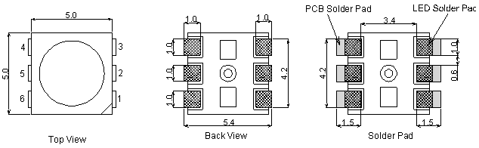
PIN configuration
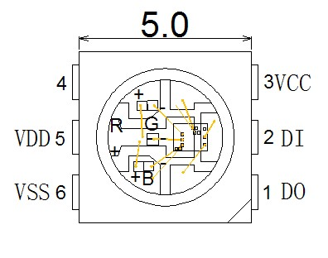
PIN function
NO. | Symbol | Function description
1 | DOUT | Control data signal output
2 | DIN | Control data signal input
3 | VCC | Power supply control circuit
4 | NC
5 | VDD | Power supply LED
6 | VSS | Ground

Absolute Maximum Ratings
Prameter | Symbol | Ratings | Unit
Power supply voltage | V_{CC} | +6.0~+7.0 | V
Power supply voltage | V_{DD} | +6.0~+7.0 | V
Input voltage | V_{I} | -0.5～VDD+0.5 | V
Operation junction temperature | Topt | -25～+80 | ℃
Storage temperature range | Tstg | -55~+150 | ℃
Electrical Characteristics（T_{A}=-20～+70℃，V_{DD}=4.5～5.5V,V_{SS}=0V,unless otherwise specified）
Prameter | Smybol | conditions | Min | Tpy | Max | Unit
Low voltage output current | I_{OL} | ROUT | —— | 18.5 | —— | mA
Low voltage output current | I_{dout} | Vo=0.4V，D_{OUT} | 10 | —— | —— | mA
Input current | I_{I} | V_{I}=V_{DD}/V_{SS} | —— | —— | ±1 | µA
Input voltage level | V_{IH} | D_{IN}，SET | 0.7V_{DD} | —— | —— | V
Input voltage level | V_{IL} | D_{IN}，SET | —— | —— | 0.3 V_{DD} | V
Hysteresis voltage | V_{H} | D_{IN}，SET | —— | 0.35 | —— | V
Switching characteristics（T_{A}=-20～+70℃，V_{DD}=4.5～5.5V,V_{SS}=0V,unless otherwise specified）
Prameter | Symbol | Condition | Min | Tpy | Max | Unit
Operation frequency | Fosc2 | —— | —— | 800 | —— | KHz
Transmission delay time | t_{PLZ} | CL=15pF,DIN→  DOUT,RL=10KΩ | —— | —— | 300 | ns
Fall time | t_{THZ} | CL=300pF,OUTR/OUTG/OUTB | —— | —— | 120 | µs
Data transmission rate | F_{MAX} | Duty ratio50% | 400 | —— | —— | Kbps
Input capcity | C_{I} | —— | —— | —— | 15 | pF

LED characteristic parameter
Emitting color | Wavelength(nm) | Luminous intensity(mcd) | Current(mA) | Voltage(V)
Red | 620-630 | 550-700 | 20 | 1.8-2.2
Green | 515-530 | 1100-1400 | 20 | 3.0-3.2
Blue | 465-475 | 200-400 | 20 | 3.2-3.4
Data transfer time( TH+TL=1.25µs±600ns)
T0H | 0 code ,high voltage time | 0.35us | ±150ns
T1H | 1 code ,high voltage time | 0.7us | ±150ns
T0L | 0 code , low voltage time | 0.8us | ±150ns
T1L | 1 code ,low voltage time | 0.6us | ±150ns
RES | low voltage time | Above 50µs

Sequence chart:

Cascade method:

Data transmission method：

Note: The data of D1 is send by MCU,and D2, D3, D4 through pixel internal reshaping amplification to transmit.
Composition of 24bit data:
G7 | G6 | G5 | G4 | G3 | G2 | G1 | G0 | R7 | R6 | R5 | R4 | R3 | R2 | R1 | R0 | B7 | B6 | B5 | B4 | B3 | B2 | B1 | B0
Note: Follow the order of GRB to sent data and the high bit sent at first.
Typical application circuit:
